Software Documentation

Software Overview
The software controls the working of a smart elevator system. It allows the user to select floors through a mobile application, sends commands to the ESP32 microcontroller, and manages the movement of the elevator using motors and sensors. It also handles floor detection using IR sensors and provides visual indication of the current floor using LEDs.
Platforms used (MicroPython, MIT App Inventor)
- MicroPython (using Thonny IDE): Used to write and upload code to the ESP32 for controlling motors, sensors, and LEDs.
- MIT App Inventor (mobile + web): Used to design the user interface and create an app that sends floor selection commands via Bluetooth.

System Logic
- • User opens the mobile app.
- • User selects the desired floor using buttons.
- • App sends the selected floor data via Bluetooth.
- • ESP32 receives the data.
- • ESP32 processes the input and determines direction (up/down).
- • Motor starts moving the elevator accordingly.
- • IR sensors detect when the elevator reaches a floor.
- • ESP32 stops the motor at the correct floor.
- • Neopixel LEDs update to indicate the current floor.

3. Flowchart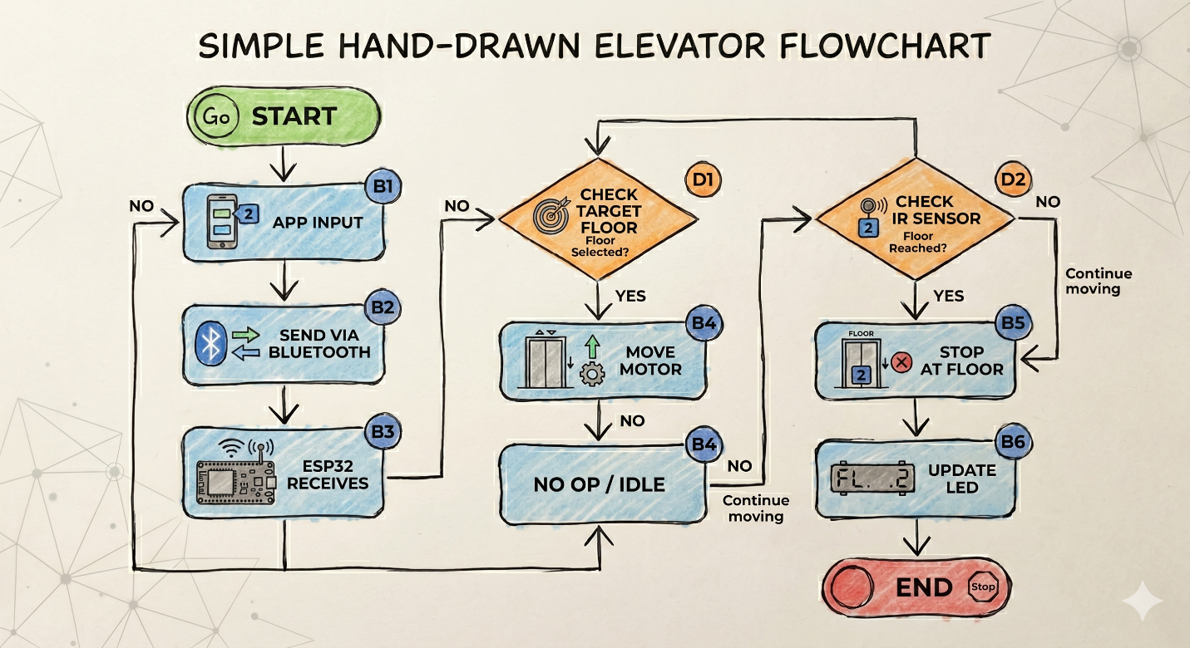

4. App Flow (If MIT App Inventor)
Screen flow:
- Main screen with floor selection buttons (Ground, Floor 1, Floor 2, etc.)
- Bluetooth connection screen (connect/disconnect device)
Button actions:
- Each floor button sends a unique value (e.g., “1”, “2”, “3”) via Bluetooth
- Connect button pairs the phone with the ESP32 Bluetooth module
Data flow:
User Input → Button Click → Bluetooth Transmission → ESP32 → Motor + Sensor Response → LED Feedback
